Stardew Valley Companion App

a report on the Design and creation a companion app

HereticalSilence

2023

Contents

1: An introduction to Stardew Valley 2

1.1: A brief synopsis of the game 2

1.2: Mechanics of the game 2

1.2.1: Crops and Seeds 2

1.2.2: Skills 2

1.2.3: Day, Night and Energy 3

2: Existing tools for Stardew Valley 4

2.1: Stardew Valley Crop Planner 4

2.1.1: What is it? 4

2.1.2: Features of the Crop Planner 4

2.1.3: So why make a new program? 4

2.2: Stardew Valley Profit Calculator 4

# An introduction to Stardew Valley

## A brief synopsis of the game

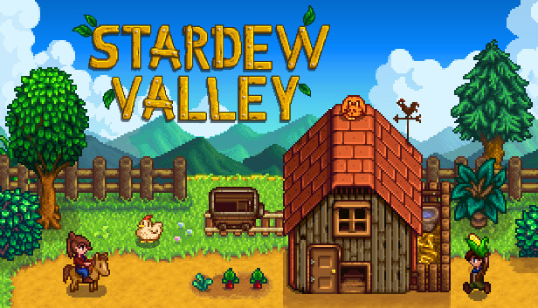Stardew Valley is an open-ended farming simulation role playing game. At the beginning of a new save the player creates a character who inherits a small plot of land and house from their grandfather in a small town called Pelican Town. Initially the farm is overrun with boulders, weeds and trees which will need to be cleared in order to farm the land and raise livestock to generate revenue. During their time in Stardew Valley the player can farm, fish, interact with non-playable characters to develop relationships and partake in marriage. After marriage the player can have or adopt a child and the spouse will tend to the farm engaging in menial but necessary tasks such as watering the crops.

Figure 1: A picture from Stardew Valley’s official Steam page showing the player character, a chicken, crops and a coop.

## Mechanics of the game

### Crops and Seeds

Stardew Valley revolves around a twenty-eight-day seasonal cycle with many crops being season specific, for example cauliflower can only be planted in Spring. Season specific crops will wither with the seasonal change meaning crops will need to be grown and planned out accordingly to ensure no wasted seeds. Crops must be watered each day in order to grow with the Watering Can or Sprinklers, once the recipe has been unlocked. Seeds can be bought from four NPCs; Pierre’s General Store, JojaMart, the Travelling Cart or Oasis. Primarily the player will be purchasing seeds from either Pierre or JojaMart, though JojaMart does charge more per seed generally unless a membership is purchased for 5000g. The Travelling Cart appears on Fridays and Sundays and offers a variety of items for a range of prices. The Oasis can only be accessed once the bus station has been repaired via completing the Vault Bundles in the Community Centre or the Joja Community Development Form for 40,000g.

### Skills

There are 5 skills that the player can upgrade: *Farming*, *Mining*, *Foraging*, *Fishing* and *Combat*. Each skill level requires more experience than the last. At skill level five the player can choose a profession and then at level ten a specialisation. The *Farming* skill is increased by harvesting planted crops and each level grants +1 proficiency to the Hoe and Watering Can tools. The *Mining* skill is upgraded by breaking boulders and ore nodes and each level grants +1 proficiency to the pickaxe. The *Foraging* skill is upgraded by chopping trees, stumps and logs and gathering wild produce from around Pelican Town, each level grants +1 axe proficiency. The *Fishing* skill is upgraded by successfully completing the fishing minigame and catching fish in the crab pot, each level grants +1 fishing proficiency and affects the minimum size of fish the player can catch. Finally, the *Combat* skill is levelled up by fighting monsters which can be found in the mines, skull cavern, on the farm if the player is playing on the Wilderness Map or selected “Spawn monsters on the farm” at a new game creation. Monsters can also spawn on the farm by offering a Strange Bun to the Dark Shrine of Night Terrors. Levelling up the Combat skill will increase the player’s maximum health points at levels one through four, and six through nine, as well as if the level five profession *Fighter* is chosen.

### Day, Night and Energy

The day begins at 6am when the player wakes up and runs until 2am where the player will pass out regardless of where they are. During the day the player can perform actions that will drain their energy. Upon reaching zero energy exhaustion and slowness modifiers are added to the player meaning they only regenerate half their energy and their movement is significantly reduced. This exhaustion modifier can be removed by consuming a Muscle Remedy or if married by kissing their spouse for the first time in the day. Increasing energy above 0 by eating energy positive foods will remove the movement penalties but not the exhaustion modifier. At -15 energy the player passes out regardless of the time and if outside of the farm will lose up to 10% of their money up to a maximum of 1000g. At the beginning of the game the character has 270 energy which can be used to mine boulders, chop down trees, farm the land and fish. At base each action, asides from fishing, requires two energy, meaning the player has 135 actions to start with, with the player. As the player upgrades their skills tool proficiencies increase lowering the cost per tool action by 0.1 per level. At level 10 each tool action only costs 1 energy.

# Existing tools for Stardew Valley

## Stardew Valley Crop Planner

### Calendar Description automatically generatedWhat is it?

Figure 2: Picture of the Stardew Valley Crop Planner as created by GitHub user Exnil.

The Stardew Valley Crop Planner is a fantastic tool allowing for multi-seasonal planning and even multi-year planning. It has a simplistic UI resembling the calendar found in game and features in game events such as festivals and birthdays. It was created by Github user Exnil using JavaScript.

### Application Description automatically generated with low confidenceText Description automatically generated with low confidenceFeatures of the Crop Planner

The planner allows for users to plant crops choosing the fertiliser and quantity of the crops. The harvest date is then added to the calendar along with how much money the crops will generate if sold as raw produce. It includes festival and birthdays on the calendar, allows you to enter your *Farming* skill level and adjusts the ratio of crop qualities according which in turn affect how much profit the calendar will show. You can also choose the two crop related profession and specialisation to affect how much profit is shown (+10%) and how fast the crops grow (+10% faster). Finally, the calendar allows for you to search crops to see how much the seeds cost at Pierre’s, the crops base sell price and the g/day.

Figure 3 and 4: Two pictures from the Crop Planner showing Cauliflowers being planted on the 1st and then harvested on the 13th as well the cost for seeds and profit.

### So why make a new program?

The Crop Planner was made for Stardew Valley version 1.1, currently (22/01/23) Stardew Valley is on version 1.5.6. This means the Crop Planner is significantly out of date and is missing key things such as new fertilisers that affect crop growth and profit meaning that currently it’s useful for planning up to a point after which you can’t use it properly.

## Stardew Valley Profit Calculator